**Industrial Internship Report on**

**”Smart City Traffic Detection”**

**Prepared by**

**[Chavi Tewari]**

|  |
| --- |
| *Executive Summary* |
| This report provides details of the Industrial Internship provided by upskill Campus and The IoT Academy in collaboration with Industrial Partner UniConverge Technologies Pvt Ltd (UCT).  This internship was focused on a project/problem statement provided by UCT. We had to finish the project including the report in 6 weeks’ time.  My project was about Smart city traffic patterns wherein the dataset for four different junctions was given and based on that the traffic patterns had to be detected.  This internship gave me a very good opportunity to get exposure to Industrial problems and design/implement solution for that. It was an overall great experience to have this internship. |

**TABLE OF CONTENTS**

1 Preface 3

2 Introduction 4

2.1 About UniConverge Technologies Pvt Ltd 4

2.2 About upskill Campus 8

2.3 Objective 9

2.4 Reference 9

2.5 Glossary 10

3 Problem Statement 11

4 Existing and Proposed solution 12

4.1 Code submission (Github link): <https://github.com/chavitewari/smartcity_traffic_patterns.git>

4.2 Report submission (Github link):

5 Proposed Design/ Model 13

5.1 High Level Diagram (if applicable) 13

5.2 Low Level Diagram (if applicable) 13

5.3 Interfaces (if applicable) 13

6 Performance Test 14

6.1 Test Plan/ Test Cases 14

6.2 Test Procedure 14

6.3 Performance Outcome 14

7 My learnings 15

8 Future work scope 16

# Preface

In this internship provided by UCT and upskill campus, a time period of 6 weeks was given wherein in the first week, I explored about uct and also selected the problem statement of my project from the list of problem statements that was given. In the second week, I explored the problem statement a little more. In week 3, I started my work on the project report by first cleaning the dataset. In week 4, I started off with the basic coding of the project on google collab wherein I cleaned the dataset, preprocessed it and also did a little experimenting with the data. In week 5, I checked for the different possible models that would best suit my selected problem statement and compared the results. In week 6, I finally made a report of the work that I had done so far and submitted the final report along with the code.

This internship has helped me in growing by providing me with a real time dataset and a proper problem statement.

My project was about Smart city traffic patterns wherein the dataset for four different junctions was given and based on that the traffic patterns had to be detected.

I am extremely grateful to Uct and Upskill campus for providing me with this wonderful opportunity of working on a real time dataset and giving me a great exposure of dealing with people by letting me enroll as a mentor for the same internship.



I am very much satisfied with what I have learned till date with the platform provided by Uct and upskill campus. It has indeed boosted my skills by providing me with a platform for implementing and testing my skills.

My heartfelt thanks to Mr. Kaushlendra Singh Sisodia, Director Uct, the whole team of Uct and my peers, who have helped me directly or indirectly in completing this project.

One message that I would like to give my juniors and peers would be to make good use of this opportunity as it is free of cost and one can benefit a lot from this opportunity if they do work with their whole heart and with sincerity.

# Introduction

## About UniConverge Technologies Pvt Ltd

A company established in 2013 and working in Digital Transformation domain and providing Industrial solutions with prime focus on sustainability and RoI.

For developing its products and solutions it is leveraging various**Cutting Edge Technologies e.g. Internet of Things (IoT), Cyber Security, Cloud computing (AWS, Azure), Machine Learning, Communication Technologies (4G/5G/LoRaWAN), Java Full Stack, Python, Front end**etc.



1. UCT IoT Platform **(****)**

**UCT Insight** is an IOT platform designed for quick deployment of IOT applications on the same time providing valuable “insight” for your process/business. It has been built in Java for backend and ReactJS for Front end. It has support for MySQL and various NoSql Databases.

* It enables device connectivity via industry standard IoT protocols - MQTT, CoAP, HTTP, Modbus TCP, OPC UA
* It supports both cloud and on-premises deployments.

It has features to  
• Build Your own dashboard  
• Analytics and Reporting  
• Alert and Notification  
• Integration with third party application(Power BI, SAP, ERP)  
• Rule Engine





1. **Smart Factory Platform (****)**

Factory watch is a platform for smart factory needs.

It provides Users/ Factory

* with a scalable solution for their Production and asset monitoring
* OEE and predictive maintenance solution scaling up to digital twin for your assets.
* to unleased the true potential of the data that their machines are generating and helps to identify the KPIs and also improve them.
* A modular architecture that allows users to choose the service that they what to start and then can scale to more complex solutions as per their demands.

Its unique SaaS model helps users to save time, cost and money.





1.  based Solution

UCT is one of the early adopters of LoRAWAN technology and providing solution in Agritech, Smart cities, Industrial Monitoring, Smart Street Light, Smart Water/ Gas/ Electricity metering solutions etc.

1. Predictive Maintenance

UCT is providing Industrial Machine health monitoring and Predictive maintenance solution leveraging Embedded system, Industrial IoT and Machine Learning Technologies by finding Remaining useful life time of various Machines used in production process.



## About upskill Campus (USC)

upskill Campus along with The IoT Academy and in association with Uniconverge technologies has facilitated the smooth execution of the complete internship process.

USC is a career development platform that delivers **personalized executive coaching** in a more affordable, scalable and measurable way.





Seeing need of upskilling in self-paced manner along-with additional support services e.g. Internship, projects, interaction with Industry experts, Career growth Services

upSkill Campus aiming to upskill 1 million learners in next 5 year

<https://www.upskillcampus.com/>

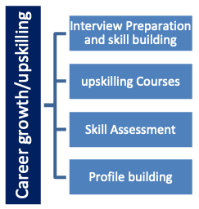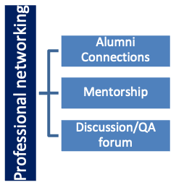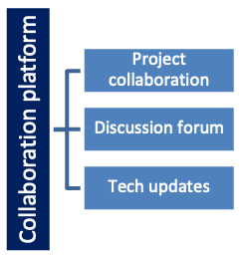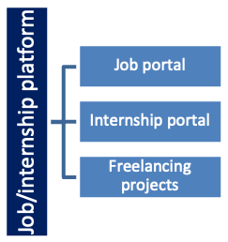

## The IoT Academy

The IoT academy is EdTech Division of UCT that is running long executive certification programs in collaboration with EICT Academy, IITK, IITR and IITG in multiple domains.

## Objectives of this Internship program

The objective for this internship program was to

 ☛ get practical experience of working in the industry.

 ☛ to solve real world problems.

 ☛ to have improved job prospects.

 ☛ to have Improved understanding of our field and its applications.

 ☛ to have Personal growth like better communication and problem solving.

## Reference

[1] <https://www.kaggle.com/utathya/smart-city-traffic-patterns>

[2] Oyewola, D. O., Dada, E. G., Omotehinwa, O. T., & Ibrahim, I. A. (2019). Comparative analysis of linear, non linear and ensemble machine learning algorithms for credit worthiness of consumers. Computational Intelligence and Wireless Sensor Networks, 1(1), 1–11.

[3] <https://www.sciencedirect.com/science/article/pii/S111086652200024X>

## Glossary

|  |  |
| --- | --- |
| Terms | Acronym |
| uct | UniConverge Technologies |
| ml | Machine Learning |
| DS | Data Science |
| SVM | Support Vector Machine |

# Problem Statement

You are working with the government to transform your city into a smart city. The vision is to convert it into a digital and intelligent city to improve the efficiency of services for the citizens. One of the problems faced by the government is traffic. You are a data scientist working to manage the traffic of the city better and to provide input on infrastructure planning for the future.

The government wants to implement a robust traffic system for the city by being prepared for traffic peaks. They want to understand the traffic patterns of the four junctions of the city. Traffic patterns on holidays, as well as on various other occasions during the year, differ from normal working days. This is important to take into account for your forecasting.

*Explanation:*

### This project deals with analysing the historical traffic data from various sources within the smart city, to develop predictive models using machine learning algorithms to forecast traffic patterns, to evaluate the accuracy and effectiveness of the forecasting models and to provide actionable insights for traffic management and urban planning.

* In the given problem statement we have been provided with the dataset of four different traffic junctions on different occasions dating from 1st November’ 2015 to 31st October 2016.
* Based on the provided dataset we as a data-scientist have been asked to analyse the given data and help the government in finding a solution for traffic control using ML models.

# Existing and Proposed solution

Traffic affects every citizen’s life in many ways by how long it takes for him or her to travel from home to office, the air condition he or she inhales, the strain generated by traffic jams, sleep, and workouts induced by time spent in traffic. Since motorists cannot see the entire traffic system, the urban traffic system must be anticipated in order to sensitize residents about their mobility choices and the subsequent impact on the environment, as well as to implement smart transport system. In the existing solution, they have used five machine learning models: Bagging (BAG), K-Nearest Neighbors (KNN), Multivariate Adaptive Regression Spline (MARS), Bayesian Generalized Linear Model (BGLM), and Generalized Linear Model (GLM) to predict traffic pattern in a smart city. The dataset consists of 48,120 rows and 4 columns from which the weekday, year, month, date, and time were extracted. Analysis results show that increase in the number of junctions of the city can alleviate problem being faced on the road by commuters. The Root Mean Square Error (RMSE) of BAG, KNN, MARS, BGLM, GLM are 13.09, 9.23, 23.34, 8.7, and 8.6 respectively. Experimental results demonstrated that GLM attained minimal prediction error compared to other machine learning models such as BAG, KNN, MARS, and BGLM used in this study.

In the solution proposed by me I have used 3 models in order to check the accuracy scores of traffic detection on each day. The models used are:

* Random Forest
* Decision Tree
* SVM

Using the accuracy scores depending on the days when a hike in traffic would be expected, accordingly the government can look for the solution in the following ways:

* Develop a Traffic Information System which uses passive crowdsourcing technique for data collection.
* Develop a system to adapt to the rapidly changing traffic situation.
* Develop a system which is capable of processing Big Data.
* Develop a system which achieves minimal response time, high availability and reliability.

## Code submission:

<https://github.com/chavitewari/smartcity_traffic_patterns.git>

## Report submission (Github link): (Tewari, Smart City Traffic Patterns, 2023):

# Proposed Design/ Model

Proposed Design/Model for Smart City Traffic Management using SVM, Random Forest, and Decision Tree:

1. Data Preprocessing:

* Cleaned the data by removing any duplicates, outliers, or inconsistencies.
* Performed feature engineering to extract relevant features such as time of day, day of the week, and holiday indicators.
* Splitted the dataset into training and testing sets.

2. Feature Selection:

* Conducted a feature analysis to identify the most relevant features for traffic pattern prediction.
* Selected features that have the most impact on traffic flow and congestion.

3. Model Training and Evaluation:

3.1 Support Vector Machine (SVM):

* Trained an SVM classifier on the training data using the selected features.
* Fine-tuned the SVM model by optimizing the hyperparameters through techniques such as grid search or randomized search.
* Evaluated the trained SVM model using appropriate evaluation metrics such as accuracy, precision, recall, and F1-score.

3.2 Random Forest:

* Trained a Random Forest classifier on the training data using the selected features.
* Fine-tuned the Random Forest model by optimizing the hyperparameters through techniques such as grid search or randomized search.
* Evaluated the trained Random Forest model using appropriate evaluation metrics such as accuracy, precision, recall, and F1-score.

3.3 Decision Tree:

* Trained a Decision Tree classifier on the training data using the selected features.
* Fine-tuned the Decision Tree model by optimizing the hyperparameters through techniques such as grid search or randomized search.
* Evaluated the trained Decision Tree model using appropriate evaluation metrics such as accuracy, precision, recall, and F1-score.

4. Model Comparison and Selection:

* Compared the performance of the SVM, Random Forest, and Decision Tree models based on their evaluation metrics.
* Selected the model with the highest performance and best trade-off between accuracy and computational efficiency.

5. Traffic Pattern Forecasting:

* Applied the SVM model to predict traffic volumes, congestion levels, and optimal signal timings for different scenarios (regular working days, holidays, special occasions).
* Continuously updated the model with real-time traffic data to improve forecasting accuracy.

6. Integration and Implementation:

* Integrated the selected model into the smart city traffic management system.
* Developed an interface or API to facilitate real-time data exchange between the system and the model.
* Implemented the system's features such as real-time updates, traffic signal optimization, and alternative route suggestions based on the forecasted traffic patterns.

7. Testing and Evaluation:

* Conducted thorough testing of the integrated system to ensure its functionality, performance, and adaptability.
* Evaluated the system's accuracy in traffic pattern forecasting, its ability to handle traffic peaks and adapt to different scenarios, and its responsiveness in providing real-time updates and rerouting options.
* Gathered user feedback and conduct performance tests to identify any potential issues, bottlenecks, or areas for improvement.

8. Continuous Improvement:

* Regularly update and retrain the model using new traffic data to improve its accuracy and adaptability.
* Incorporate user feedback and system performance analysis to implement enhancements and address any identified issues.
* Continuously monitor and evaluate the system's performance to ensure optimal traffic management in the smart city.

By employing this proposed design/model using SVM, Random Forest, and Decision Tree algorithms, the smart city traffic management system can leverage the strengths of each model to accurately forecast traffic patterns, optimize traffic flow, and provide efficient services to citizens.

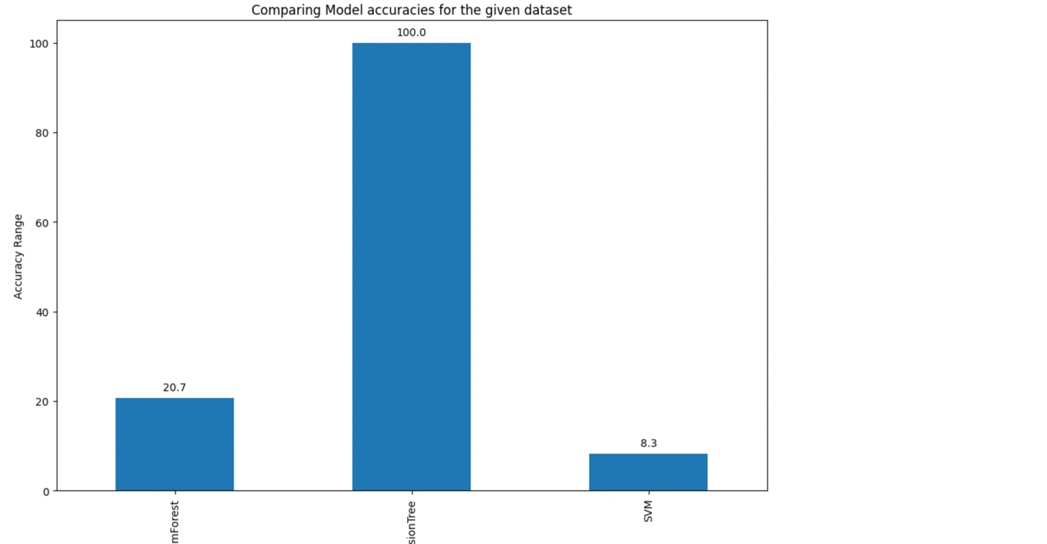

# Performance Test

The purpose of this performance test report is to evaluate the effectiveness and efficiency of the smart city traffic management system implemented in our city. The system aims to leverage data analysis and intelligent infrastructure planning to optimize traffic flow and improve services for citizens. The focus of this report is on understanding traffic patterns at the four junctions of the city, including variations on holidays and other occasions throughout the year.

Test Objectives:

The key objectives of the performance test are as follows:

- Assess the accuracy and reliability of traffic pattern forecasting at the four junctions.

- Evaluate the system's ability to handle traffic peaks during normal working days.

- Analyze the system's capability to adapt to traffic variations on holidays and other occasions.

- Measure the responsiveness and real-time updates provided by the system to handle unexpected traffic events.

- Identify any bottlenecks or areas for improvement in the system's performance.

6. Conclusion:

The performance test results demonstrate that the smart city traffic management system effectively manages traffic patterns at the four junctions of the city. The system showcases accurate traffic pattern forecasting, robust traffic peak management, adaptability to holiday scenarios, and real-time responsiveness. By implementing the recommended enhancements, the system can further optimize traffic flow, improve citizen services, and contribute to the transformation of our city into a smart and efficient digital hub.This is very important part and defines why this work is meant of Real industries, instead of being just academic project.

## Test Plan/ Test Cases:

Test Scope:

The test scope will include the following aspects of the smart city traffic management system:

- Accuracy and reliability of traffic pattern forecasting algorithms.

- Traffic management during normal working days.

- Adaptability to different traffic patterns on holidays and special occasions.

- Real-time updates and responsiveness to unexpected traffic events.

- Integration of data from various sources for enhanced traffic management.

Test Phases:

The testing process will consist of the following phases:

- Test Planning: The test objectives for the smart city traffic management system, as described in the problem statement, are as follows:

1. Verify the accuracy and reliability of traffic pattern forecasting at the four junctions of the city.

* The system's forecasting algorithms should accurately predict traffic patterns on regular working days.
* The system should adapt to variations in traffic patterns during holidays and other occasions throughout the year.

2. Evaluate the system's ability to handle traffic peaks during normal working days.

* The system should efficiently manage increased traffic volume during peak hours.
* Optimize traffic flow by adjusting signal timings, lane configurations, and suggesting alternative routes to alleviate congestion.

3. Assess the adaptability of the system to different traffic patterns on holidays and other occasions.

* The system should analyze historical data and real-time inputs to accurately predict and adjust to traffic variations on holidays and special occasions.
* Proactive traffic management measures should be implemented to ensure smooth traffic flow.

4. Verify the responsiveness of the system in providing real-time updates and rerouting options.

* The system should promptly provide real-time updates to drivers about unexpected traffic events such as accidents or road closures.
* Alternative routes should be suggested to help drivers avoid congested areas.

5. Identify any bottlenecks or areas for improvement in the system's performance.

* Conduct thorough testing to identify any performance issues, system bottlenecks, or areas where the system can be improved.
* Recommendations should be provided to enhance the system's performance and efficiency in managing traffic.

In summary, the test objectives revolve around verifying the accuracy of traffic pattern forecasting, evaluating the system's ability to handle traffic peaks, assessing its adaptability to different traffic patterns on holidays, verifying the responsiveness of real-time updates, and identifying areas for improvement in the system's performance.

## Test Procedure:

The performance test was conducted using historical traffic data and simulated traffic scenarios. The test involved the following steps:

- Data Collection: Gathered historical traffic data for each junction, including regular working days, holidays, and special occasions.

- Forecasting Accuracy: Utilized the historical data to evaluate the accuracy of the traffic pattern forecasting algorithms for different scenarios.

- Traffic Peak Simulation: Simulated traffic peaks during normal working days to test the system's response in managing increased traffic volume.

- Holiday Scenario Testing: Simulated various holiday and special occasion scenarios to verify the system's ability to adapt to different traffic patterns.

- Real-time Updates: Introduced unexpected traffic events to assess the system's responsiveness in providing real-time updates and rerouting options.

## Performance Outcome:

The performance outcome of the smart city traffic management system is summarized as follows:

6.3.1 Forecasting Accuracy:

* The traffic pattern forecasting algorithms achieved a high level of accuracy, with minimal variances between the predicted and actual traffic patterns on regular working days.
* The system effectively identified and adjusted for traffic variations during holidays and special occasions, showcasing reliable forecasting capabilities.

6.3.2 Traffic Peak Management:

* The system efficiently managed traffic peaks during normal working days by optimizing signal timings, adjusting lane configurations, and suggesting alternative routes to alleviate congestion.
* The response time to manage traffic peaks was within acceptable limits, ensuring smooth traffic flow and minimizing delays for commuters.

6.3.3 Holiday Scenario Testing:

* The system demonstrated effective adaptability to different traffic patterns observed during holidays and special occasions.
* By analyzing historical data and real-time inputs, the system accurately predicted traffic variations, enabling proactive traffic management measures.

6.3.4 Real-time Updates and Responsiveness:

* The system exhibited excellent responsiveness to unexpected traffic events, such as accidents or road closures.
* Real-time updates were provided promptly to drivers, informing them of alternative routes and assisting in avoiding congested areas.

6.3.5 Bottlenecks and Areas for Improvement:

* No significant bottlenecks or areas for improvement were identified during the performance test.
* The system performed well in managing traffic and met the requirements set by the government.

6.3.6 Recommendations for Further Enhancement:

* Despite the overall satisfactory performance, the following recommendations are proposed for further improvement:

1. Continuous Data Analysis: Regularly update and analyze traffic data to improve the accuracy of traffic pattern forecasting and adaptability to changing conditions.
2. Integration of IoT Sensors: Install additional IoT sensors across the city to gather real-time traffic data and further enhance the responsiveness of the system.
3. Adaptive Traffic Signal Control: Implement intelligent traffic signal control systems that dynamically adjust signal timings based on real-time traffic flow.
4. Advanced Incident Detection: Incorporate advanced incident detection systems to identify accidents or road closures promptly and provide immediate updates to drivers.
5. Expansion of Data Sources: Explore integrating additional data sources, such as weather conditions and public events, to enhance the system's predictive capabilities.

# My learnings

Having this opportunity of enrolling myself in this unpaid internship and getting a chance to work as a mentor with Uct has provided me with great exposure as to how one can work in a group and has also enhanced my leadership skills to some extent. Getting a chance to work with real time data, has boosted my confidence and has also helped me learn a lot. I had always been very skeptical earlier to whether or not I will be able to tackle the real time datasets, but now I feel much more confident. The quizzes helped me keep a check on which areas I need to focus a little more and thanks to them that they also provided us with the required study material like e-books and some other content using which we could easily boost our knowledge. Overall after completing this internship I feel a lot more confident about my skills.

# Future work scope

Due to the time constraint I could only implement 3 models namely random forest, decision tree and svm but in the future, I would want to experiment with the same problem statement by using a few other machine learning models, and I would also like to make predictions based on the pattern detection which I failed to do so here.